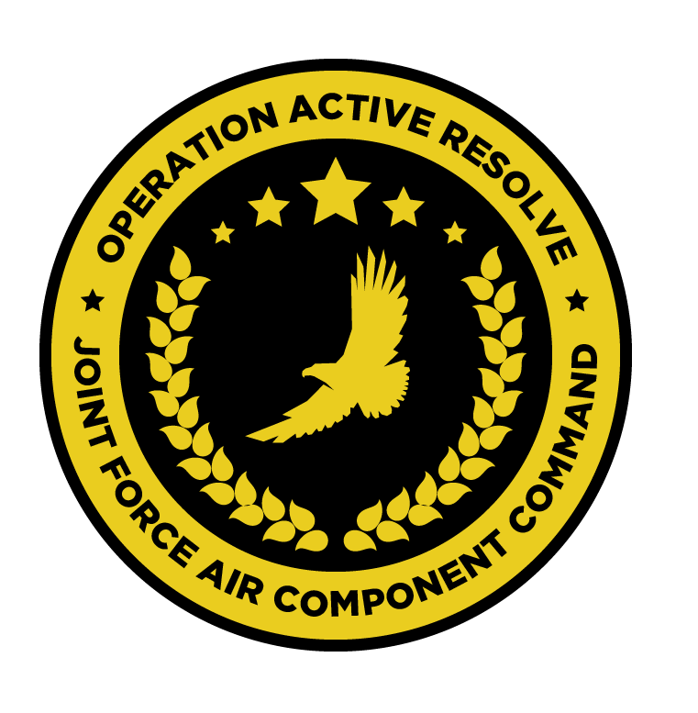

JFACC JOINT AIR OPERATIONS PLAN

OPERATION ACTIVE RESOLVE

# Situation.

*TBD*

## Adversary Forces.

*TBD*

## Friendly Forces.

*TBD*

# Mission.

JFACC will establish air superiority in the area of operations, and defeat Syrian offensive capability in support of CJTF-82 offensive operations to neutralize Syrian offensive capability to conduct offensives in the region.

# Air Operations

## Joint force air organization.

* 132nd Virtual Wing
  + 617th Squadron: A10C
  + 696th Squadron: KA-50
  + 259th Squadron: MI-8
  + 494th Squadron: F/A-18C
  + 108th Squadron:F-14B
  + 388th Squadron: F-16C
  + 23rd JTAC Squadron
  + 176th AWACS Squadron: E-3
* 7 WEDS: MI-8
* KC-135 MPRS Squadron
* KC-135 Squadron
* 2x Patriot Battalions

## Joint force air objectives.

1. Destroy Syrian WMD capability.
2. Establish and maintain air superiority over Turkey and Israel.
3. Establish and maintain air superiority over Syria for completion of CJTF-82 objectives.
4. Degrade Syrian ground forces.
5. Execute AI campaign to :
   1. Neutralize Syrian long term offensive capability in the region.
   2. Reduce Syrian will to conduct military operations in the region

## Beddown overview.

* 132nd Virtual Wing: Split between Incirlik and Ramat David Airbase
  + 617th: 1 detachement Incirlik and one detachment at Ramat David Airbase
  + 696th: 1 detachement Incirlik and one detachment at Ramat David Airbase
  + 259th: 1 detachement Incirlik and one detachment at Ramat David Airbase
  + 388th: 1 detachement Incirlik and one detachment at Ramat David Airbase
  + 494th Squadron: Carrier
  + 108th Squadron: Carrier
* 7 WEDS (MI-8): Split between Incirlik and Ramat David Airbase
* KC-135 MPRS Squadron: Incirlik
* KC-135 Squadron: Incirlik
* E-3 Squadron: Incirlik
* Patriot BN 1: Incirlik
* Patriot BN 2: Ramat David Airbase

## Phases of joint air operations in relation to CJTF operation

### Timing and duration of phases.

* Phase 1: Shaping
  + Phase 1.1: DCA + Support ground forces
    - D+1 to D+4
  + Phase 1.2: DCA+ Support ground forces + OCA
    - D+5 to D+8
* Phase 2: Decisive action
  + Phase 2.1: DCA+Support ground forces+ OCA
    - D+9 to D+11
  + Phase 2.2: DCA+Support ground forces + Air Interdiction
    - D+11 to D+25
* Phase 3: Stabilization
  + Phase 3.1: DCA+ Support ground forces
    - D+26-D+35

### Phase 1. Shaping

In phase 1.1 focus of the air operations will be the conduct DCA in order to protect own assets and stop Syrian aggression from the air in Turkish and Israeli airspace in order to protect own ground forces from Syrian air attacks.

Support to own ground forces by attacking Syrian ground forces in Israel and Turkey will continue.

In phase 1.2 focus will shift from DCA to OCA in order to reduce Syrian ability to project power from the air into Turkey and Israel.

DCA operations will continue to protect own ground forces from Syrian air attacks.

Support to own ground forces by attacking Syrian ground forces in Israel and Turkey will continue.

### Phase 2. Decisive action

In phase 2.1 focus of the air operations will be the continuation of OCA to achieve air superiority over own ground forces and defeat the Syrian air defenses in order to set conditions for air interdiction operations.

Support to own ground forces by attacking the Syrian ground forces will continue as own ground force commences their attack into Syria in this phase.

DCA operations will continue to protect own ground forces from Syrian air attacks.

In phase 2.2 focus of the air operations will shift from OCA to Air Interdiction in order to destroy the long term Syrian ability to conduct offensives in the region.

Support to own ground forces by attacking the Syrian ground forces will continue as own ground force continues their attack into Syria.

DCA operations will continue to protect high value assets such as AWACS, Carrier or tankers.

### Phase 3. Stabilization

In phase 3.1 primary focus will be to support own ground forces conducting counter insurgency operations as Syrian Air forces is defeated and Syrian ground forces offensive capability have been destroyed.

DCA operations will continue to protect high value assets such as AWACS, Carrier or tankers.

## Master Air Attack Plan (MAAP)

* Destroy/ neutralize air defense command and control.
* Destroy nuclear, biological and chemical storage and production capability.
* Make ineffective the Syrian national and military command, control and communications infrastructure.
* Destroy key electrical grids and oil storage facilities.
* Destroy POL infrastructure (Petroleum, Oil, Lubricants)
* Deny military resupply capability.
* Reduce Syrian repair capability.
* Eliminate Syrian long-term offensive capability.
* Make the Syrian ground forces ineffective.

## Coordinating Instructions.

* Civilian air traffic is expected in and out of Beirut, Lebanon. Civilian traffic will follow published routes in Airspace Control Plan (ACP).
* Civilian air traffic is expected in and out of Haifa, Israel. Civilian traffic will follow published routes in Airspace Control Plan (ACP).
* Civilian air traffic is expected in and out of Adana, Turkey. Civilian traffic will follow published routes in Airspace Control Plan (ACP).
* All other civilian airfields in Turkey, Israel and Lebanon is closed.
* Civilian air traffic is expected in Syrian from the EAST (via corridor in Iraq into easter Syria). No civilian air traffic is going from WEST into Syria. Civilian traffic will normally follow published routes in Airspace Control Plan (ACP).
* JFACC will on behalf of CJTF-82 provide an advisory to civilian air traffic to avoid Syria once phase 2 of the operation is underway. (JFACC responsibility).
* All JFACC units will pay attention to avoid any downing of civilian air traffic.

## Expected sortie availability (for planning purposes)

* A-10: 2-6
* F/A-18: 4-8
* F-16: 2-6
* F-14:2-6
* KA-50: 2-6
* MI-8:2 (259th + 7 WEDS)
* KC-135:3
* E-3:1-2

### Surge operations:

Supporting assets, such as KC-135 , KC-135 MPRS and E-3 can surge their operations for one ATO day (increasing their numbers by one, but the next event will then have one aircraft less due to maintainance). Decision to conduct surge operations rests with JFACC and is ordered in the AOD if required.

# Logistics.

* C-17 and C-130s will establish regular resupply into Ramat David and Incirlick Airbases for delivery of high priority items.

# Command. Control. and Communications

## Command

* All RW operations is controlled by JFACC
* All naval air operations is controlled by JFACC

Chain of command:

JFACC --> AOC --> AWACS --> (Mission Commander) --> Flight lead

Mission commander only relevant for COMAO/Package operations tasked as such on the ATO.

* AOC breaks down guidance and priority from JFACC into an executable Air Tasking Order (ATO).
* During execution of the ATO, AWACS is delegated authority from JFACC and AOC to execute the mission in accordance with (IAW) JAOP, AOD and ATO
* Daily a AOD will be published from JFACC that provides updated guidance, priorities and allocation. AOD D+1 will give guidance for ATO D+2.
* Daily a ATO will be published, based on the AOD.
* (Daily= Per event. 1 event/1 day= 14 day cycle minimum

## Communications

**CombatFlite files:**

* Airspace Control Plan: All navpoints, CP/IP, tanker tracks, FAOR, No-fly zone etc
  + Availeble on website Updated by AOC.
* Target overlay
  + Availeble on website Updated by VIS/JFACC.
* Intelligence overlay
  + Availeble on website Updated by VIS.